SACRED HEART PARISH

Sacred Heart Parish Founded 1814, The First Catholic Parish in the STate of New Jersey

Sacred Heart Church, 343 South broad Street, Trenton, New Jersey 08608

Holy Cross Church, 233 Adeline Street, Trenton, New Jersey 08611

ALL ARE WELCOME

Whatever your present status in the Catholic Church, whatever your current family or marital situation,

Whatever your past or present religious affiliation, whatever your personal history, age, background, or

race, whatever your own self-image or esteem, you are invited, welcomed, accepted, loved and

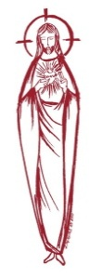
respected at the Parish of the Sacred Heart.
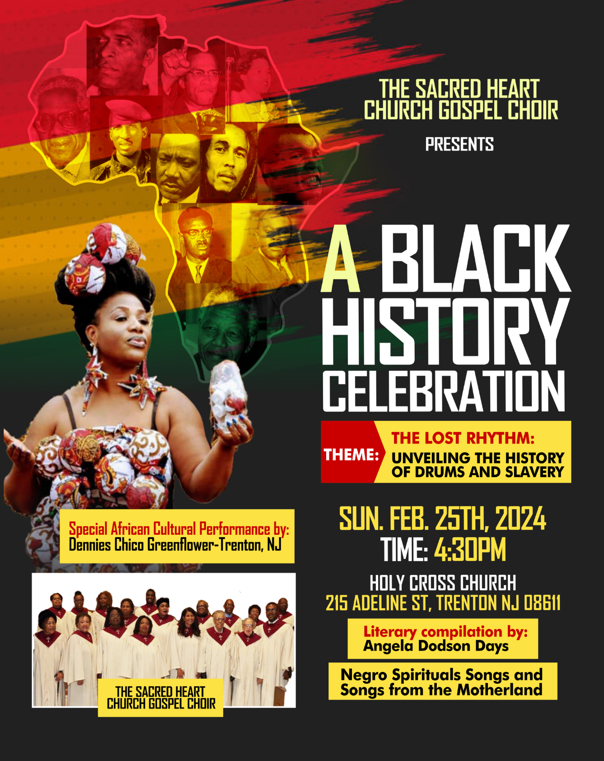

SECOND SUNDAY OF LENT ~ FEBRUARY 25,2024

MASS INTENTIONS
Saturday, February 24
4:00 pm HCC ~ Paul Glazewski
5:15 pm SHC ~ Robert Spinachetti
Sunday, February 25
9:00 SH ~ Edward T. Schrader Sr.
10:00 HCC~ Donald Mize
11:15 SH ~ The intentions of the People of the Parish
12:00 HCC Polish ~ B. Companick, Dariusz Suszko, and Maciej Sokolowski
Monday, February 26
8:00 HCC ~ Special Intentions
12:10 SHC~ Ray Kostura
Tuesday, February 27
12:10 pm SHC ~ Jean DeAngelo
Wednesday, February 28
12:10 pm SHC ~ Wilma Ruberto
Thursday, February 29
8:00 am HCC ~ Raymond R. Klama
Friday, March 1
8:00 am HCC ~ Jean Birndorf
12:10 pm SHC ~ Joyce Reed
Saturday, March 2
4:00pm HCC~ Deceased Members of Jesencky Family
5:15 pm SHC ~ Betty O’Neill and Vito Erkoboni
Sunday, March 3
9:00 SH ~ Carmella Staaub
10:00HCC~ The intentions of the People of the Parish
11:15 SH ~ Vladimir Chernichov & Mary Chernichov
12:00 HCC Polish ~ Maciej Sokolowski

OUR SICK LIST
Beth Fitzpatrick, Judy Brown, BJ Matthews, Marg Herpel, Jose Gonzalez, Mary Sokolowski, Rocco, Lorraine Wargo, Robert Paci, David Carver, Jennifer Lyons, Grace Profy, Steve Jurczynski, Cornell Hess, Ruby Covington, Judith Santigo, Dan Breese Jr, Brenna Kennedy-Moore, Mark Friedman, Alexander A. Ladnyk, Lauren Clayton, Joseph Edralin, Margie Tiongson, Vincent Cooper, Jr., Gail Ladnyk, Leo Genovesi, Richard Buckley, Tony Ragolia, Barbara Burrows, Charles Burrows, Dorothy Amoroso, Maryann Sullivan, Regina Friedman, Stanley Winowicz, Greg Schafer, Jack Hardiman, Amy Birk, Julia Grazioli, Matt Tydryszewski.

OUR DECEASED
Helen Smith, Sheila Gavin, and our friends at South Village, Riverside Nursing and Rehabilitation Center, Mill House and Waters Edge.

MINISTRY SCHEDULE
(Subject to Change)
Saturday, Feb 24
4:00pm HCC ~ Fr Charles L.: V. Zielinski Em.: E. Zielinski
5:15pm SHC ~ Msgr. Dennis L.: N. Kazior Em.: J. Kazior, Needed
Sunday, Feb 25
9:00 FrDennis L.: K. Valentino,Em. R.&K.Figueroa, K. Jurczynski
10:00 HCC ~ Fr. Charles L.: O. Nnadi Em.: F. Kollie
11:15 F Dennis L.: M. Rhodes-Rogers,Em.: S. Jurczynski, M. Ortiz
12:00 HCC Polish ~ Fr Marian Anna
Saturday, March 2
4:00pm HCC ~ Fr Charles L.: F. Zielinski Em.: A. Lennon
5:15pm Msgr. Dennis L.: L. SeabrookEm.: W. Lewis, M. Salamandra
Sunday, March 3
9:00 Msgr. Dennis L.: Y. LaurentiEm.: Komjathy, H. Mangan, G. Mowenn
10:00 HCC ~ Fr. Charles L.: R. Nnajiofor Em.: O. Nnadi
11:15 SHC ~ Msgr. Dennis L.: M. RhodesEm.: N. Rhodes, T. Rizzuto
12:00 HCC Polish ~ TBA

WEEKLY COLLECTION
Last weekend’s collection amounted to $8,833.00. This includes the donations received in Church and the mail ins. Thank you for your continued support of our parish.

READINGS FOR THE WEEK
Second Week of Lent
Sunday Gn 22:1--18; Rom 8:31b-34; Mk 9:2-10
Monday Dn 9:4b-10; Lk 6:36-38
Tuesday Is 1:10, 16-20; Mt 23:1-12
Wednesday Jer 18:18-20; Mt 20:17-28
Thursday Jer 17:5-10; Lk 16:19-31
First Friday Gn 37:3--28a; Mt 21:33-43, 45-46
Saturday Mi 7:14-15, 18-20; Lk 15:1-3, 11-32

PROMISE TO PROTECT
The Diocese of Trenton is committed to the norms of the U.S. Bishop’s Charter for the Protection of Children and Young People in regard to the reporting and investigation of sexual abuse allegations involving minors. If you have been sexually abused as a minor by anyone representing the Catholic Church, you can report that abuse through the diocesan Hotline: 1-888-296-2965 or abuseline@dioceseoftrenton.org. Allegations are reported to the appropriate law enforcement agencies.

REBATE FROM 2023
ANNUAL CATHOLIC APPEAL
This past week, we received a rebate check from the Diocese of Trenton’s Annual Catholic Appeal Office for the 2023 calendar year. As promised, we received 15% of our goal of $33,000.00 and 50% of everything over our goal which amounted to $11,613.50. Our total satisfied pledge amounted to $46,442.00 which is 141% of our original goal. Thank you so much to all who participated and supported the appeal. I am grateful for your generosity. Our Bishop is delighted with the success of our cooperation with the appeal. Thank you and God Bless you.

THE SACRED HEART CHURCH GOSPEL CHOIR
Presents
A BLACK HISTORY CELEBRATION
~The Lost Rhythm: Unveiling the History of Drums and Slavery~
On Sunday, February 25th at 4:30 PM in
Holy Cross Church 215 Adeline Street.
Negro Spiritual Songs
and Songs from the Motherland.
Literary compilation by:
Angela Dodson Days

EASTER BAZAAR & BAKE SALE
The Sisterhood at St. Josaphat's will hold its annual Easter Bazaar and Bake Sale on Friday, March 22, and Saturday, March 23, 2024.
Accepting orders through March 10. Call Daria 609-585-7863 or Slava 609-585-1294 or email Marta at: juzeniwmarta@gmail.com
*Pierogies $11/dz* Stuffed Cabbage $3*
*Easter Babka with or without raisins*
*medium $10, large $14*
*Poppyseed Roll* Fruit or Nut Roll $15*
Pick up orders in lower hall of parish center
at 1199 Deutz Avenue Trenton, NJ 08611.
Thank you for your support!

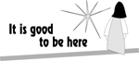

LENT
MERCER COUNTY LENTEN PILGRIMAGE
Week February 25, 2024 Schedule
You are invited to journey to some of the Churches throughout Mercer County to celebrate evening Mass and get to visit some of the beautiful churches of Mercer County.
This week’s station Churches are:
Monday, February 26 ~ St. John The Baptist (7:00 PM) ~ 1282 Yardville-Allentown Road, Allentown NJ
Tuesday, February 27 ~ St. Mary Cathedral (7:00 PM) ~ 151 North Warren Street, Trenton, NJ
Wednesday, February 28 ~ Incarnation Church (7:00 PM) ~ 1545 Pennington Rd, Ewing Township,
Thursday, February 29 ~ Our Lady of Sorrows
(7:00 PM) ~ 3816 East State Street Ext., Hamilton, NJ

ALTAR ROSARY SOCIETY
All rosarians, future rosarians, people of our parish are warmly welcomed to join us on Sunday, March 3rd , 9:00am Mass at Sacred Heart Church. The rosary will be prayed before Mass. Following Mass, a meeting will take place at Toomey Hall. Stop by, meet the members and enjoy light refreshments. We are a church support group of dedicated Catholic people who serve our Blessed Mother, our Parish. Hear about the good the Rosarians do for our parish community. God Bless you all. We are looking forward to your participation. Any questions, please call Joan Buckley @ 609-396-7063.
FIRST PENANCE
Nine children of our parish will receive the Sacrament of Reconciliation this coming Saturday. Please keep them in your prayers.
CONFIRMATION
As a part of the process for the reception of the Sacrament of Confirmation our students in the 8th Grade Religious Education Program will be interview this comint Saturday . Please keep them in our prayers.
ADORATION
Adoration of the Blessed Sacrament will take place on Saturday March 2nd , in Holy Cross Church at 2:30 pm. All are welcome to come
and pray .
February 25 SECOND SUNDAY OF LENT
Gn 22 ; 1-18 Ps 116 Rom 8:31 -34 MK 9:2-10
~Sacred Heart Church: Mass celebrated at 9:00am and 11:15
~Stations prayed after the 9:00am Mass
~Holy Cross Church: Mass celebrated at
10:00am (Gospel Mass) 12:00 Noon (Polish Mass) The Lamentations will follow the Mass

February 26 Monday Lenten
Weekday
Dn 9:4b-10/Lk 6:36-38
~Holy Cross Church Mass celebrated at 8:00am
~Sacred Heart Church Mass celebrated at 12:10 noon ~ Saints for Sinners program following the Mass in 1 Centre Street, this week’s video is: Saint John Bosco ~ Mercer County Lenten
Pilgrimage at St. John The Baptist Church 7:00 PM 1282 Yardville-Allentown Road, Allentown

February 27 Tuesday Lenten
Weekday
Is 1 – 20 Ps 50: 8-23 Mt 23 1- 12
~ Sacred Heart Church Mass celebrated at 12:10 noon ~ Rosary prayed after Mass ~
Sacred Heart Church Confessions 5:00 pm to 6:00pm. ~ Mercer County Lenten Pilgrimage at St Mary Cathedral 7:00 PM ~ 151 North Warren Street, Trenton

February 28~ Wednesday Lenten Weekday
Jer 18:18-20/Mt 20:17-28
~Sacred Heart Church Mass celebrated at 12:10 noon ~Holy Cross Church confessions 5:00pm to 6:00pm ~ Mercer County Lenten Pilgrimage at Incarnation Church, 7:00 PM ~ 1545 Pennington Rd, Ewing Township

February 29 Thursday Lenten Weekday
Jer 17:5-10/Lk 16:19-31
~Holy Cross Church Mass celebrated at 8:00am ~Mercer County Lenten Pilgrimage at Our Lady of Sorrows Church
7:00 PM ~ 3816 East State Street Ext., Hamilton

March 1 Friday Lenten Weekday
Gn 37:3-4, 12-13a, 17b-28a/Mt 21:33-43, 45-46
~Day of Abstinence ~ Mass celebrated at 8:00 am at Holy Cross Church ~Mass celebrated at 12:10 noon at Sacred Heart Church ~Stations of the Cross at 12:00 noon at Holy Cross Church ~ Stations of the Cross in Polish at 6:30 pm at Holy Cross Church

March 2 Saturday Lenten Weekday
Mi 7: 14 – 20 Ps 103 1– 12, Luke 15: 1 – 32
Lenten Program: Jesus ACTion will be held in Toomey Hall under Sacred Heart Church from 10:00am to 11:30 am
~Adoration of the Blessed Sacrament will be held in Holy Cross Church from 2:30 to 3:30pm ~ Confessions at Holy Cross Church from 3:30 to 3:50 pm ~ Mass celebrated at 4:00 pm at Holy Cross Church ~ Confessions at Sacred Heart Church from 4:30 to 5:00 pm ~ Mass celebrated at 5:15 pm at Sacred Heart Church

STATIONS OF THE CROSS
The Stations of the Cross will be prayed every Friday at 12:00 noon at Holy Cross Church and every Sunday following the 9:00 Mass at Sacred Heart. Stations of the Cross will be prayed in Polish on Friday evenings at 6:30pm in Holy Cross Church.
SACRAMENT OF RECONCILIATION
The Sacrament of Reconciliation will be offered from 3:30 to 3:50 pm on Saturday’s in Holy Cross Church and from 4:30 to 5:00 pm in Sacred Heart Church. Additional times for confession include: Holy Cross on Wednesday evening from 5:00 to 6:00 and at Sacred Heart on Tuesday evening from 5:00 pm to 6:00 pm. Another option is to call the parish office for an appointment.

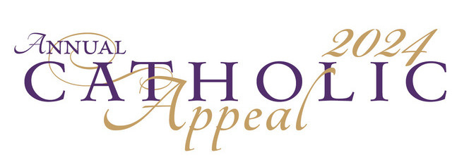
DIOCESE OF TRENTON ANNUAL CATHOLIC APPEAL 2024

Dear Brothers and Sisters,

Today, I invite you to be a part of something truly special— the Annual Catholic Appeal! This year's theme, "One Love, One Faith, One Family," mirrors the teachings of Christ and resonates with the wisdom of Colossians: “And over all these virtues put on love, which binds them all together in perfect unity” (Colossians 3:14). This profound and perfect love reinforces our shared belief in one God, inspiring us to become pillars of compassion and support for each other.

A gift to the appeal becomes a lifeline for families in need, supports the education of our youth in the faith, and empowers individuals on their journey to become religious leaders, such as Deacons and Catechists, serving our parishes and communities with wisdom and faith. Your support also sustains our retired priests, allowing them to continue offering guidance, and provides essential resources to our Catholic school principals and teachers, ensuring an education grounded in faith and values.
May God bless you abundantly for your generosity and commitment to our church. Join us on this journey, hand in hand, as we embody the spirit of "One Love, One Faith, One Family."

With every good wish, I remain
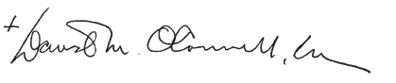
Most Reverend David M. O’Connell, C.M.
Bishop of Trenton

Drogie Siostry i Bracia,

Zapraszam Państwa do wzięcia udziału w czymś naprawdę wyjątkowym — Dorocznej Kweście Katolickiej! Tegoroczne motto to „Jedna miłość, jedna wiara, jedna rodzina”. Odzwierciedla ono nauki Chrystusa i współgra z mądrością zawartą w Liście do Kolosan: „Na to zaś wszystko [przyobleczcie] miłość, która jest więzią doskonałości.” (List do Kolosan 3,14) To właśnie ta głęboka i doskonała miłość wzmacnia naszą wspólną wiarę w jednego Boga, inspirując nas, abyśmy stali się ostoją współczucia i wzajemnego wsparcia.
Dar na rzecz kwesty staje się ratunkiem dla potrzebujących rodzin, wspiera wychowanie naszej młodzieży w wierze i wzmacnia ludzi na ich drodze do zostania przywódcami religijnymi w postaci diakonów i katechistów, służących swą mądrością i wiarą naszym parafiom i wspólnotom. Państwa pomoc wspiera także naszych emerytowanych księży, umożliwiając im dalszą posługę dla innych, a także zapewnia niezbędne zasoby dyrektorom i nauczycielom naszych szkół katolickich, zapewniając edukację opartą na wierze i wartościach.
Niech Pan Bóg obficie błogosławi za Państwa hojność i zaangażowanie na rzecz naszego Kościoła. Zapraszamy Państwa, aby dołączyli do nas w tej podróży, ramię w ramię, podczas której ucieleśniamy ducha „Jednej miłości, jednej wiary, jednej rodziny”.
Z najlepszymi życzeniami Jego Ekscelencja Ksiądz Biskup David M. O’Connell,
Zgromadzenie Księży Misjonarzy Biskup Trenton
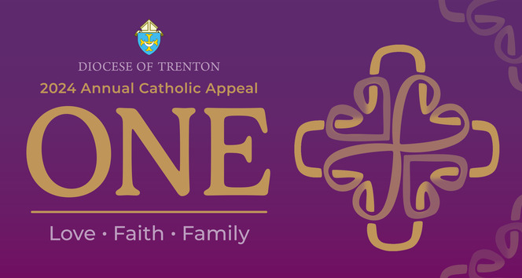

OUR GOAL
This weekend will be Collection Weekend at our parish. Sacred Heart Parish has a goal of $33,000.00 to pledge. Thank you to those parishioners who have already made their gift to the 2024 Annual Appeal. Will you join your fellow parishioners in supporting this effort that strengthens many important programs and ministries across the Diocese of Trenton? Our goal, can only be achieved through YOUR generosity! If you have not yet made a gift, there will be pledge forms available in the back of church, or you can visit: www.dioceseoftrenton.org/catholicappeal. Your gift will truly make a difference. Please be sure to indicate Sacred Heart Parish, Trenton. Thank you for your prayers and support.

FAQ 1. Who benefits from the Annual Catholic Appeal? Every parish and all people within them benefit from the Annual Catholic Appeal, as well as those who turn to the Diocese for charitable and spiritual assistance. 2. What is the goal of the Annual Appeal? The goal of the 2024 Annual Catholic Appeal is $6.5 million, however the needs of the Diocese far exceed $6.5 million. It will be to the benefit of the ministries that are supported by the Annual Catholic Appeal to be as successful as possible. 3. How can I make a gift to the Annual Appeal? • Donate online at dioceseoftrenton.org/ catholicappeal • Make a gift over the phone at 609-403-7197 • Fill out an in-pew card at your parish • Complete and return the pledge card you received in the mail • Gifts of stock, IRA distributions, bequests and charitable annuities can be coordinated by contacting Christine Prete at 609-403-7218 or cprete@dioceseoftrenton.org 4. What payments methods can I use to make a gift? Cash, check, money order, credit card, or electronic transfer from your bank account. Digital Wallets: Paypal, Apple Pay, Venmo, MasterPass, and VisaCheckout can be made by visiting dioceseoftrenton.org/catholicappeal Scan QR Code with your phones camera on all available Annual Catholic Appeal materials. 5. Where should they send their pledge/gift? Your check should be made payable to: 2024 Annual Catholic Appeal 701 Lawrenceville Road Trenton, NJ 08648 6. Can a donor make a matching gift? Yes! Donors can go to www.dioceseoftrenton. org/matching-gifts to search the matching gift database to see if their employer is eligible to match their gift. If their company is not listed it is encouraged for the donor to speak with a representative at their company and see if religious organizations are eligible to receive matching gift funds. If your gift is eligible, simply print out or request a matching gift form from your employer, and send it, completed and signed, along with your gift to the Annual Catholic Appeal Office at: Diocese of Trenton Annual Catholic Appeal 701 Lawrenceville Road Trenton, NJ 08648 7. Can a donor make an IRA charitable gift? Yes. IRA charitable gifts such as a Required Minimum Distribution (RMD) gifts. Please contact: Christine Prete cprete@dioceseoftrenton.org 8. How can I learn more or make a Planned Gift? Contact Christine Prete at 609-403-7218 or visit: dioceseoftrenton.plannedgiving.org/ to learn more. 9. Can a donor make a stock gift? Yes, please contact Christine Prete at 609-403-7218 or cprete@dioceseoftrenton.org

